Lesson 7 – Day – 2 – Working with Tab Layout Swipe views using ViewPages.

Tab Layout Example with new Kotlin support Library. Create a TabLayout with three tabs such as HOME, WORK , and CONTACT.

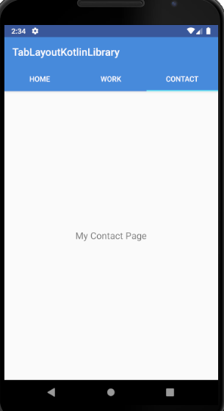

Step 1 : Add the below dependency on your build.gradle

This dependency gives the material design support to your app, we used TabLayout, Viewpager, AppBarLayout and Toolbar UI in the layout from this support library

implementation **'com.google.android.material:material:1.0.0'**

Gradle system takes time to Sync. Wait until get success.

Step 2: Design your activity_main.xml Layout file

Our parent view will be ConstraintLayout. To make a toolbar where application name comes and tabs below it, we need to add AppBarLayout. Now, we will put toolbar and tablayout inside it.

To show the content of each tab, we will require fragment and to show fragment on screen we will again use the ViewPager.

Just copy the below code into your activity_main.xml

*<?***xml version="1.0" encoding="utf-8"***?>*<**androidx.constraintlayout.widget.ConstraintLayout xmlns:android="http://schemas.android.com/apk/res/android"  
 xmlns:app="http://schemas.android.com/apk/res-auto"  
 android:layout_width="match_parent"  
 android:layout_height="match_parent"**>  
  
 <**com.google.android.material.appbar.AppBarLayout  
 android:id="@+id/appBarLayout"  
 android:layout_width="match_parent"  
 android:layout_height="wrap_content"  
 android:theme="@style/ThemeOverlay.AppCompat.Dark.ActionBar"  
 app:layout_constraintBottom_toTopOf="@+id/viewPager"  
 app:layout_constraintEnd_toEndOf="parent"  
 app:layout_constraintStart_toStartOf="parent"  
 app:layout_constraintTop_toTopOf="parent"**>  
  
 <**androidx.appcompat.widget.Toolbar  
 android:id="@+id/toolbar"  
 android:layout_width="match_parent"  
 android:layout_height="?attr/actionBarSize"  
 android:background="?attr/colorPrimary"  
 app:popupTheme="@style/ThemeOverlay.AppCompat.Light"** />  
  
 <**com.google.android.material.tabs.TabLayout  
 android:id="@+id/tabs"  
 android:layout_width="match_parent"  
 android:layout_height="wrap_content"  
 app:tabBackground="@color/colorPrimary"  
 app:tabGravity="fill"  
 app:tabMode="fixed"  
 app:tabTextColor="@android:color/white"** />  
 </**com.google.android.material.appbar.AppBarLayout**>  
  
 <**androidx.viewpager.widget.ViewPager  
 android:id="@+id/viewPager"  
 android:layout_width="match_parent"  
 android:layout_height="0dp"  
 app:layout_constraintBottom_toBottomOf="parent"  
 app:layout_constraintEnd_toEndOf="parent"  
 app:layout_constraintStart_toStartOf="parent"  
 app:layout_constraintTop_toBottomOf="@+id/appBarLayout"**>  
  
 </**androidx.viewpager.widget.ViewPager**>  
</**androidx.constraintlayout.widget.ConstraintLayout**>

Step 3: From the above code we customize the Appbar and Toolbar themes. So go to your styles.xml and change the <**style name="AppTheme" parent="Theme.AppCompat.Light.DarkActionBar"**>

As mentioned below

<**style name="AppTheme" parent="Theme.AppCompat.Light.NoActionBar"**>

Step 4: we need to create three fragment classes and their three respective layouts.

Fragment 1 : HomeFragment, File🡪New🡪Fragment🡪Fragement(Blank)

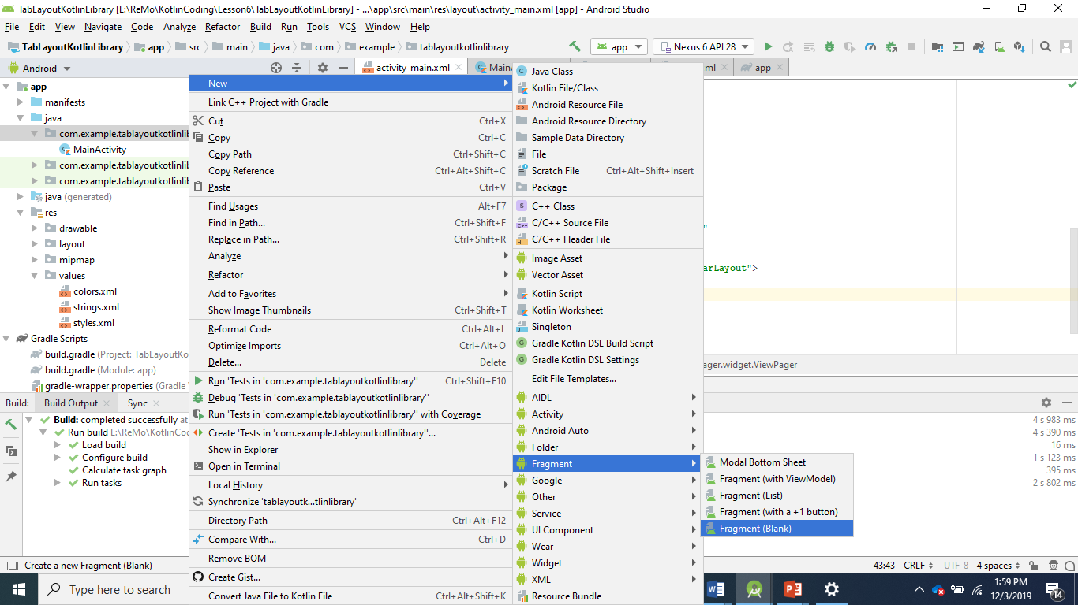

Step 5 : After doing the Step 4, you will get the below screen. Give the name for the Fragment and untick the highlighted part.

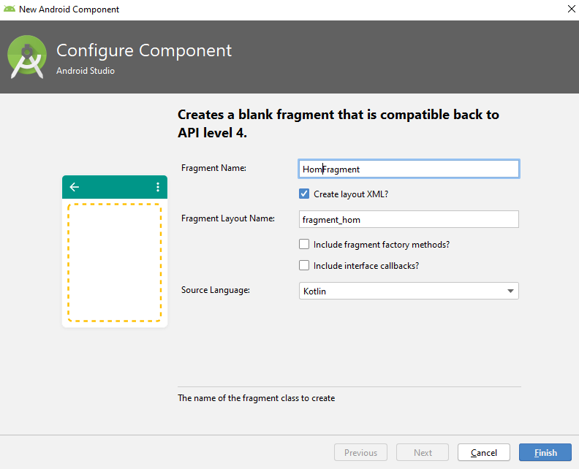

Step 6: You will the auto generated code for the fragment and layout, as mentioned below.

HomeFragment.kt

**import** android.os.Bundle  
**import** androidx.fragment.app.Fragment  
**import** android.view.LayoutInflater  
**import** android.view.View  
**import** android.view.ViewGroup  
  
**class** HomeFragment : Fragment() {  
  
 **override fun** onCreateView(  
 inflater: LayoutInflater, container: ViewGroup?,  
 savedInstanceState: Bundle?  
 ): View? {  
 *// Inflate the layout for this fragment* **return** inflater.inflate(R.layout.*fragment_home*, container, **false**)  
 }  
}

fragment_home.xml ( Just modified and added Gravity and textSize attributes).

*<?***xml version="1.0" encoding="utf-8"***?>*<**FrameLayout xmlns:android="http://schemas.android.com/apk/res/android"  
 xmlns:tools="http://schemas.android.com/tools"  
 android:layout_width="match_parent"  
 android:layout_height="match_parent"  
 tools:context=".HomeFragment"**>  
  
 *<!--* ***TODO: Update blank fragment layout*** *-->* <**TextView  
 android:layout_width="match_parent"  
 android:layout_height="match_parent"  
 android:text="My Home Page"  
 android:textSize="18sp"  
 android:gravity="center"** />  
  
</**FrameLayout**>

Step 7 : Repeat the step 4 and step 5, for creating WorkFragment and ContactFragment

**WorkFragment.kt**

**import** android.os.Bundle  
**import** androidx.fragment.app.Fragment  
**import** android.view.LayoutInflater  
**import** android.view.View  
**import** android.view.ViewGroup  
  
  
**class** WorkFragment : Fragment() {  
  
 **override fun** onCreateView(  
 inflater: LayoutInflater, container: ViewGroup?,  
 savedInstanceState: Bundle?  
 ): View? {  
 *// Inflate the layout for this fragment* **return** inflater.inflate(R.layout.*fragment_work*, container, **false**)  
 }  
}

fragment_work.xml

*<?***xml version="1.0" encoding="utf-8"***?>*<**FrameLayout xmlns:android="http://schemas.android.com/apk/res/android"  
 xmlns:tools="http://schemas.android.com/tools"  
 android:layout_width="match_parent"  
 android:layout_height="match_parent"  
 tools:context=".WorkFragment"**>  
 <**TextView  
 android:layout_width="match_parent"  
 android:layout_height="match_parent"  
 android:text="My Work Page"  
 android:textSize="18sp"  
 android:gravity="center"**/>  
  
</**FrameLayout**>

ContactFragment.kt

**import** android.os.Bundle  
**import** androidx.fragment.app.Fragment  
**import** android.view.LayoutInflater  
**import** android.view.View  
**import** android.view.ViewGroup  
  
**class** ContactFragment : Fragment() {  
  
 **override fun** onCreateView(  
 inflater: LayoutInflater, container: ViewGroup?,  
 savedInstanceState: Bundle?  
 ): View? {  
 *// Inflate the layout for this fragment* **return** inflater.inflate(R.layout.*fragment_contact*, container, **false**)  
 }  
  
  
}

fragment_contact.xml

*<?***xml version="1.0" encoding="utf-8"***?>*<**FrameLayout xmlns:android="http://schemas.android.com/apk/res/android"  
 xmlns:tools="http://schemas.android.com/tools"  
 android:layout_width="match_parent"  
 android:layout_height="match_parent"  
 tools:context=".ContactFragment"**>  
  
 *<!--* ***TODO: Update blank fragment layout*** *-->* <**TextView  
 android:layout_width="match_parent"  
 android:layout_height="match_parent"  
 android:text="My Contact Page"  
 android:textSize="18sp"  
 android:gravity="center"**/>  
  
</**FrameLayout**>

Step 8: Right Click on your Project Explorer New🡪 Kotlin File/Class

To connect all our fragments with the ViewPager, we need an adapter class. Here, we are creating ViewPagerAdapter class and implementing the FragmentStatePagerAdapter or FragmentPagerAdapter.

In this class, we will pass the list of fragment class instance and the title which we need to show on the tabs. FragmentStatePagerAdapter’s override method will help us to get the count of the tab, the title of the tab and which fragment on which position.

Create a ViewPageAdapter class as mentioned below, use the same imports, you will an error, need to override the methods.

At last, from our MainActivity which is our host activity of all the fragment, we wire up the viewPager with the adapter class. Also, we will bind our viewPager with our TabLayout.

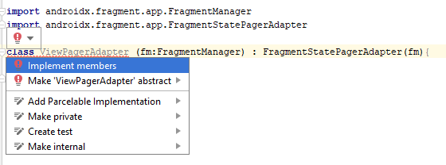

Click all the implemented methods and select OK

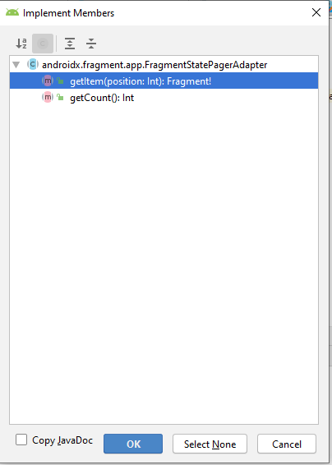

Complete code ViewPagerAdapter.kt

**import** androidx.fragment.app.Fragment  
**import** androidx.fragment.app.FragmentManager  
**import** androidx.fragment.app.FragmentStatePagerAdapter  
  
**class** ViewPagerAdapter (fm:FragmentManager) : FragmentStatePagerAdapter(fm){  
 **private val mFragmentList** = ArrayList<Fragment>()  
 **private val mFragmentTitleList** = ArrayList<String>()  
 *// return the right fragment tabbed* **override fun** getItem(position: Int): Fragment {  
 **return mFragmentList**[position]  
 }  
 *// return the count of tabs* **override fun** getCount(): Int {  
 **return mFragmentList**.**size** }  
 **override fun** getPageTitle(position: Int): CharSequence? {  
 **return mFragmentTitleList**[position]  
 }  
  
 **fun** addFragment(fragment: Fragment, title: String) {  
 **mFragmentList**.add(fragment)  
 **mFragmentTitleList**.add(title)  
 }  
}

Step 9 : MainActivity.kt

**import** androidx.appcompat.app.AppCompatActivity  
**import** android.os.Bundle  
**import** kotlinx.android.synthetic.main.activity_main.*  
  
**class** MainActivity : AppCompatActivity() {  
 **override fun** onCreate(savedInstanceState: Bundle?) {  
 **super**.onCreate(savedInstanceState)  
 setContentView(R.layout.*activity_main*)  
 *// Set the toolbar into your appbar in onCreate* setSupportActionBar(toolbar)  
 *// Create an object of ViewPagerAdapter by passing supportFragmentManager* **val** adapter = ViewPagerAdapter(*supportFragmentManager*)  
 *// Call the addFragment to add Fragment tabs and Tab Title* adapter.addFragment(HomeFragment(), **"HOME"**)  
 adapter.addFragment(WorkFragment(), **"WORK"**)  
 adapter.addFragment(ContactFragment(), **"CONTACT"**)  
 *// set your adpater to the ViewPager UI on the Layout* viewPager.*adapter* = adapter  
 *// set the ViewPager to the respective tabs* tabs.setupWithViewPager(viewPager)  
 }  
}